Universal Asynchronous Receiver Transmitter

Introduction
UART, or Universal Asynchronous Receiver/Transmitter, is a full duplex hardware communication protocol used for serial data transmission between two devices. It's a simple, two-wire system (transmit and receive) that's widely used for device-to-device communication, particularly in embedded systems. UARTs handle the conversion between parallel data (used by the controlling device) and serial data (transmitted over the communication lines).
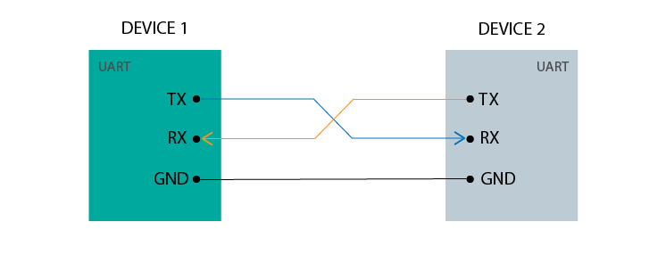

Contents
Introduction 2
UART Transmitter 4

UART Transmitter
  - Block Diagram
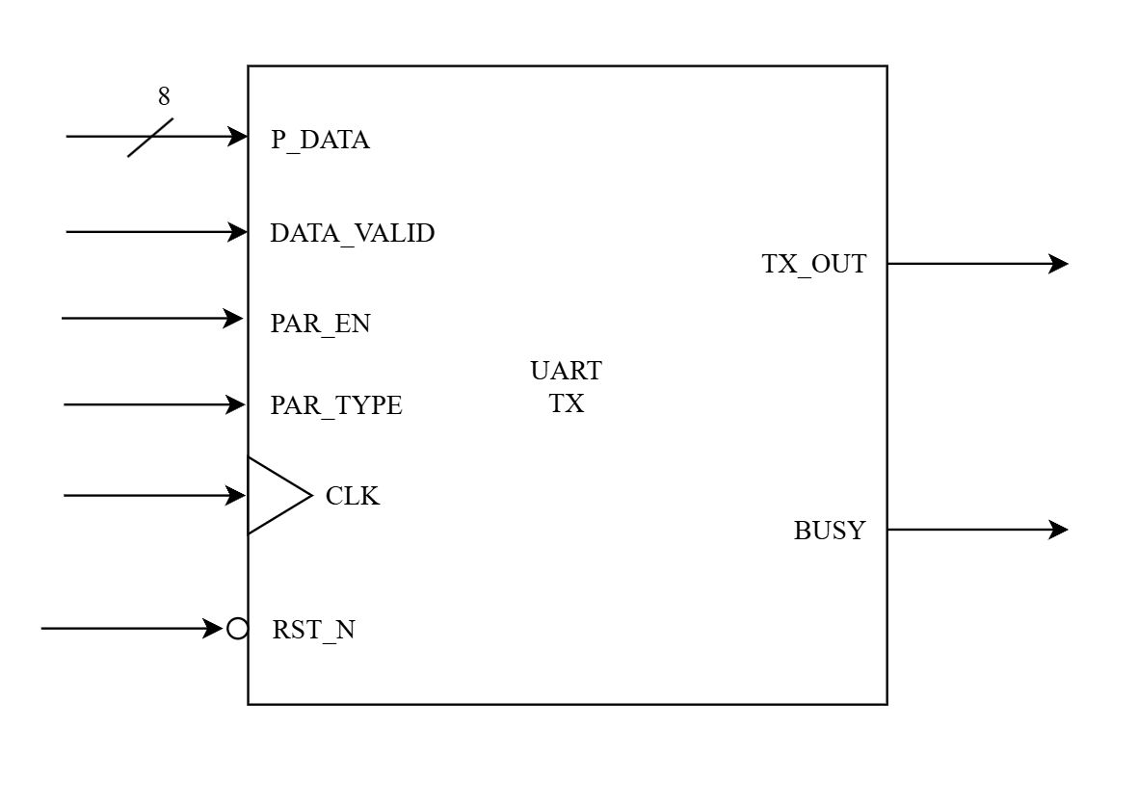
Port | Direction | Width (bits) | Description
P_DATA | INPUT | 8 | Input data byte
DATA_VALID | INPUT | 1 | High, when data is available on the data bus (P_DATA)
PAR_EN | INPUT | 1 | High to enable parity calculation
PAR_TYPE | INPUT | 1 | Parity Type  0: Even Parity bit  1: Odd Parity bit
CLK | INPUT | 1 | Input clk signal
RST_N | INPUT | 1 | Active low Asynchronous reset signal
TX_OUT | OUTPUT | 1 | Serial output data line
BUSY | OUTPUT | 1 | High signal during transmission, otherwise low

  - Verilog Modules
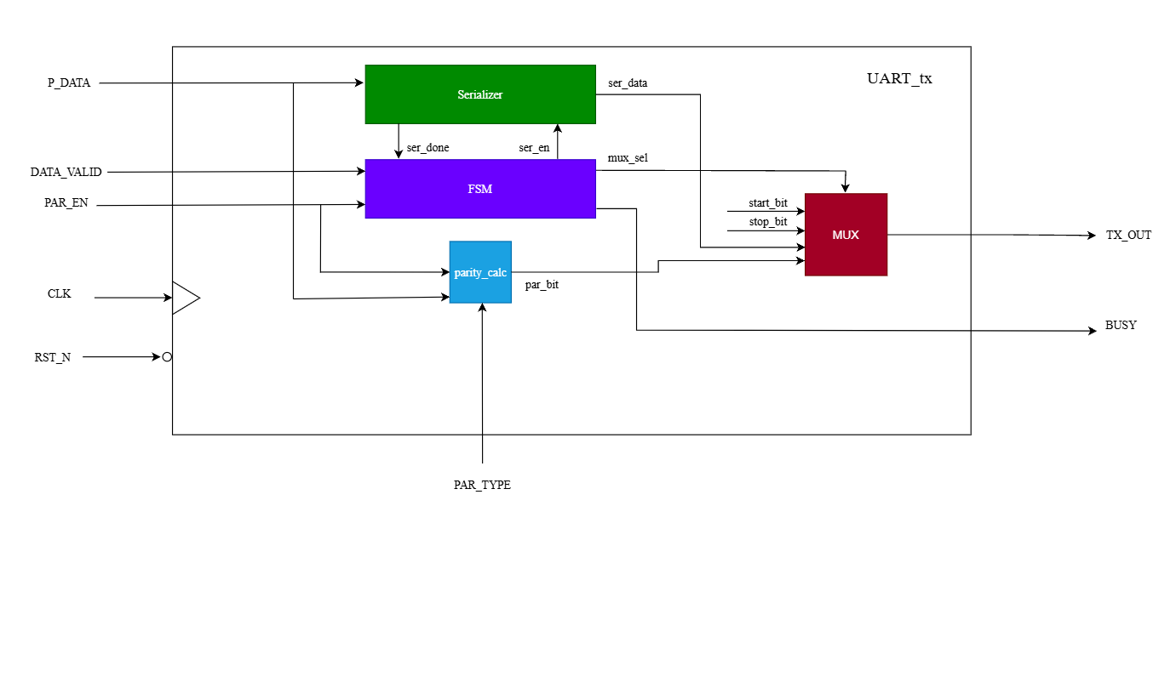
- Serializer
module serializer(
input clk,
input rst_n,
input ser_en,
input [7:0] P_DATA,
output reg ser_done,
output reg ser_data
);

integer counter;
reg [7:0] shift_reg;

always @(posedge clk, negedge rst_n) begin
if (!rst_n) begin
shift_reg <= P_DATA;
counter <= 0;
ser_data <= 1'b1; // IDLE line
ser_done <= 1'b0;
end
else if (ser_en) begin
ser_data <= shift_reg[0];
shift_reg <= shift_reg >> 1;
counter <= counter + 1;
ser_done <= (counter >= 7);
end
else begin
shift_reg <= P_DATA;
ser_data <= 1'b1; // IDLE line
end
end

- FSM
module fsm (
input Data_Valid,
input PAR_EN,
input ser_done,
input clk, rst_n,
output reg ser_en,
output reg busy,
output reg [1:0] mux_sel
);

localparam [2:0] IDLE = 3'b000,
START = 3'b001,
PARITY = 3'b011,
STOP = 3'b010;

reg [2:0] ps, ns;

// state memory
always @(posedge clk or negedge rst_n) begin
if (!rst_n) begin
ps <= IDLE;
end
else
ps <= ns;
end

// transion and output logic
always @(*) begin
ns = ps;
ser_en = 0;
busy = 0;
mux_sel = 2'b10;
case (ps)
IDLE: begin
if (Data_Valid) begin
ns = START;
mux_sel = 2'b00; // start bit
busy = 1;
ser_en = 1;
end
else
ns = IDLE;
end

START: begin
busy = 1;
mux_sel = 2'b10; // Send data
if (ser_done) begin
ns = PAR_EN? PARITY : STOP;
end else begin
ser_en = 1;
ns = START;
end
end

PARITY: begin
busy = 1;
mux_sel = 2'b11; // parity bit

if (ser_done)
ns = STOP;
else
ser_en = 1;
end

STOP: begin
busy = 0;
mux_sel = 2'b01; //stop bit
if (ser_done)
ns = IDLE;
else
ser_en = 1;
end

default: ns = IDLE;
endcase
end

endmodule

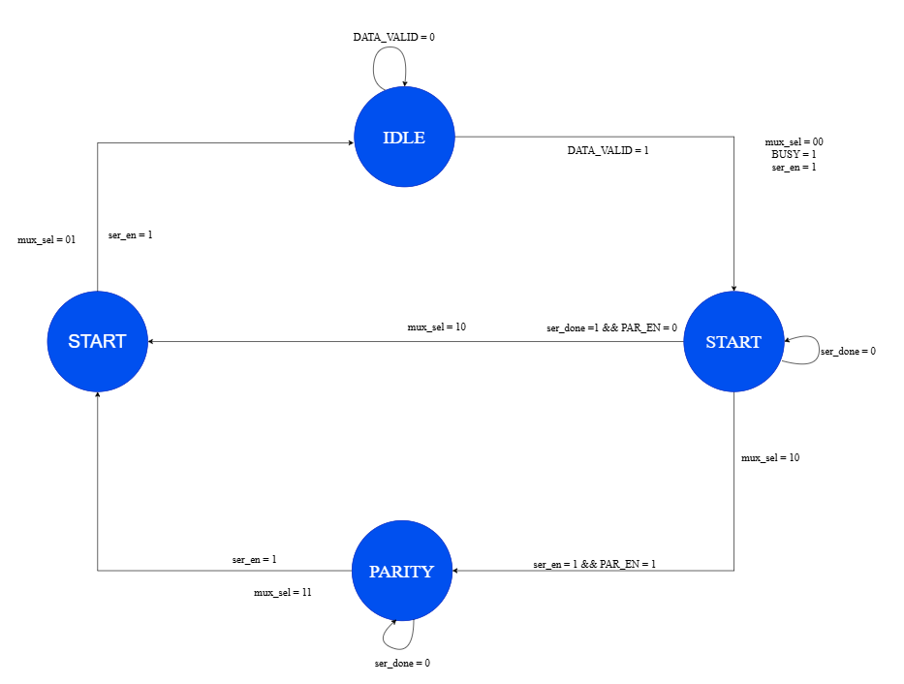
- Parity Calc
module parity_calc(
input PAR_EN,
input [7:0] P_DATA,
input PAR_TYPE,
output reg par_bit
);

always @(*) begin
if (!PAR_EN)
par_bit = 0;
else
par_bit = (PAR_TYPE)? ~(^P_DATA) : (^P_DATA); // xor reduction
end

endmodule

- MUX
module mux_4to1(
input [3:0] I,
input [1:0] mux_sel,
output Y
);

assign Y = I[mux_sel];

endmodule

- UART_tx (Top)
module uart_tx(
input [7:0] P_DATA,
input DATA_VALID,
input PAR_EN, PAR_TYP,
input clk, rst_n,
output TX_OUT, Busy
);

wire ser_en, ser_done, ser_data, par_bit;
wire [1:0] mux_sel;

serializer ser (clk,rst_n,ser_en,P_DATA,ser_done,ser_data);

parity_calc par (PAR_EN, P_DATA, PAR_TYP, par_bit);

fsm FSM (DATA_VALID,PAR_EN,ser_done,clk,rst_n,ser_en, Busy, mux_sel);

mux_4to1 mux ({par_bit, ser_data, 1'b1, 1'b0},mux_sel,TX_OUT);

endmodule

  - Results and Waveform
- Test case 1: Send 8'b10101010, no parity
initial begin
rst_n = 0; DATA_VALID = 0; PAR_EN = 0; PAR_TYP = 0; P_DATA = 8'b0;

#10
P_DATA = 8'b10101010;
#10
rst_n = 1;

// Frame 1: Send 8'b10101010, no parity
#10
DATA_VALID = 1;
PAR_EN = 0;
#10
DATA_VALID = 0; // one clk cycle high

#150

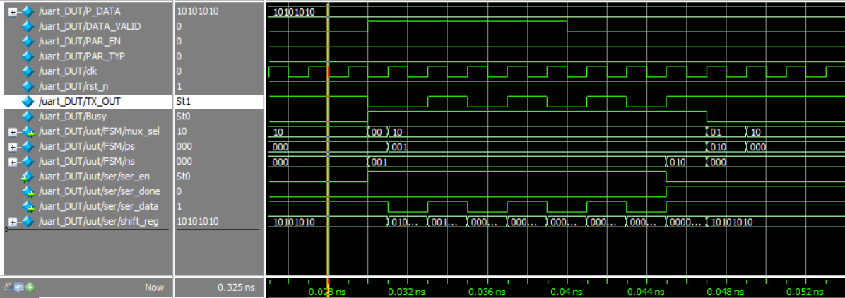
Stop
IDLE
IDLE
0
0
0
1
1
1
1
0
Start

- Test Case 2: Send 8'b01001101 with odd parity
// Frame 2: Send 8'b01001101 with odd parity
rst_n = 0; DATA_VALID = 0; PAR_EN = 0; PAR_TYP = 0;
#10;
P_DATA = 8'b01001101;
#10
rst_n = 1;
#10
DATA_VALID = 1;
PAR_EN = 1;
PAR_TYP = 1;
#5 DATA_VALID = 0;

#100;
$stop;
end

